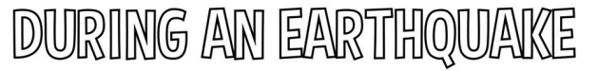

Add the missing letters to tell Rocket what to do to stay safe during an earthquake.

When the ground sh____kes or you get an a_____ert, you should: dro_____ where you are, ____over your head and neck, and _____old on.

Draw a line to match the words to the correct picture of Rocket. The first one has been done for you!

