Name: ________________________ ShakeAlert Earthquake Drill Lesson

How much water do I think I use each day . . . ?
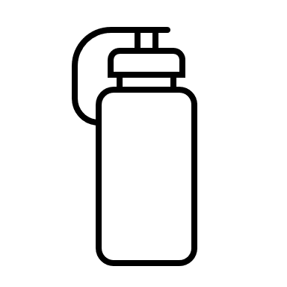  To drink:  cups | 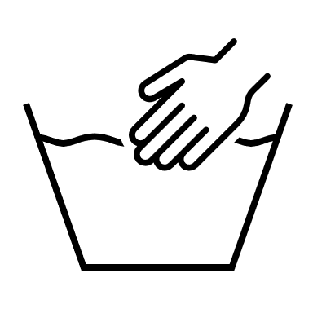  To wash:  cups | 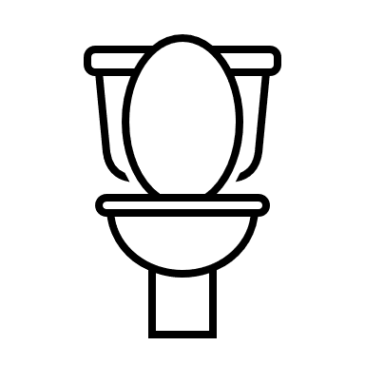  To flush the toilet:  cups
Other uses? ________  cups | Other uses? ________  cups | Other uses? ________  cups
How many total cups do you estimate you need per day?

Drinking Washing Flushing Other Other Other Total

+
+
+
+
+
=

Use the space below to show your work on how you added up the cups.

Emergency Water Needs
In an emergency, each person needs cups of water which is equal to gallon(s) per day. | 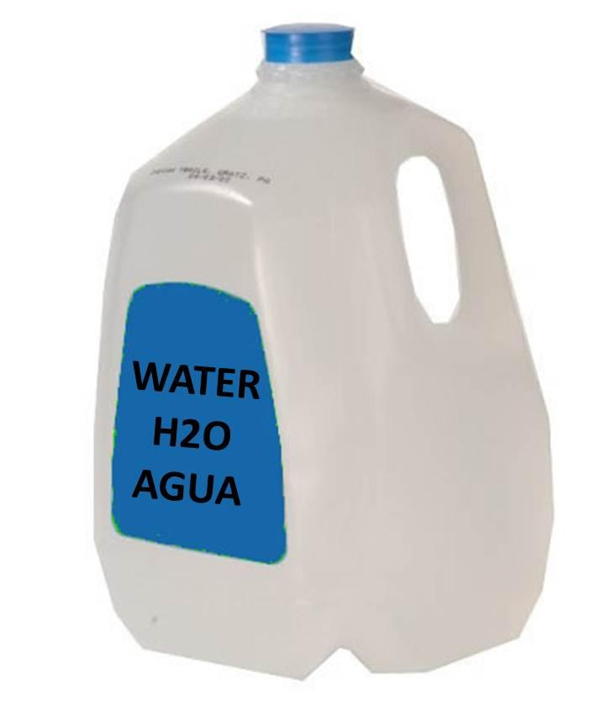  cups =
My estimate is (circle one): less than equal to greater than

My Family’s Emergency Water Needs
Each person needs  gallon per day. | We have people in my family. |  | We should have days of water stored.
The total number of gallons needed for 3 days for my family is gallons. |  |  | Show how you  figured that out in the space below!
Solve
Modeling |  | Equations
Are there people or pets in my home that may need more than one gallon of water per day? If so, how much more might we need?

Reflection
The most important thing I learned today about staying safe during an earthquake is _______________________________________________
__________________________________________________________

